ConsumerIQ: AI-Powered Consumer Purchase Behavior Analytics
An Integrated E-Commerce Analytics Dashboard Using ETL, RFM, Market Basket Analysis, Machine Learning and Explainable AI
P. Aashish (2420030500) | P. Umesh (2420030027)
KLH University — Department of Data Analytics and Visualization
Academic Year 2026–2027

Abstract — E-commerce platforms generate extensive data about orders, customers, products, purchasing frequency and transaction value, yet this information is often scattered across disconnected sources and analyzed in isolation. This paper presents ConsumerIQ, a unified multi-platform e-commerce intelligence dashboard that fuses the UCI Online Retail II, Instacart Online Grocery Orders and Olist Brazilian E-Commerce datasets into a single analytical pipeline covering Extract-Transform-Load (ETL) processing, exploratory data analysis, Recency-Frequency-Monetary (RFM) segmentation, K-Means clustering, Apriori market basket analysis, Random Forest churn prediction and SHAP-based explainable AI (XAI). We situate the system within a review of eighteen related studies spanning churn prediction, RFM-based segmentation, association rule mining, explainable AI and BI dashboard design, and benchmark the reported churn model — 66.9% accuracy, 14.3% precision, 70.5% recall, 0.238 F1-score and 0.720 ROC-AUC on 1,715,849 unified records — against comparable published results. The unified dataset spans 215,357 orders, 108,996 customers and $34,618,964 in reported revenue. The comparison shows that ConsumerIQ trades precision for recall relative to tuned, resampled literature baselines, which we attribute to class imbalance and the absence of threshold calibration rather than to the underlying pipeline design. ConsumerIQ is therefore best read as a validated, reproducible prototype for integrated consumer analytics that requires further temporal validation, probability calibration and business-cost evaluation before operational deployment.
Keywords — e-commerce analytics; customer segmentation; RFM; Apriori; churn prediction; Random Forest; SHAP; Streamlit; explainable AI; literature review.

1. INTRODUCTION
The growth of digital commerce has created an opportunity for organizations to use transaction data to understand customers and improve business decisions. Every order can contain information about product preferences, purchase timing, order value, customer activity and category relationships. When these signals are combined, they can support customer segmentation, cross-selling, retention planning and performance monitoring [1], [14].
ConsumerIQ is designed as an integrated analytical environment for this purpose. It harmonizes three independent e-commerce datasets into a common schema and presents seven dashboard tabs covering data overview, temporal trends, category distributions, RFM segmentation, market basket analysis, churn prediction and explainable AI. The project is implemented in Python using a functional programming approach and Streamlit for interactive presentation [37].

1.1 Research Problem
A central problem in retail analytics is the separation of descriptive, predictive and explanatory tasks. A dashboard may show revenue trends without explaining customer groups, or it may produce a churn score without showing why the score was generated [3], [10]. ConsumerIQ addresses this fragmentation by combining data engineering, customer analytics, machine learning and model interpretation in one workflow, and by benchmarking its own predictive results against the wider churn-prediction literature rather than reporting metrics in isolation.

1.2 Objectives
- Integrate three public e-commerce datasets into a shared analytical schema.
- Survey and position the system against existing churn-prediction, segmentation, market-basket and XAI literature.
- Perform data cleaning, harmonization and validation.
- Calculate RFM measures and create customer segments using K-Means.
- Identify category-level product associations using Apriori.
- Train and evaluate a Random Forest churn classifier and compare it with existing published methods.
- Provide global and local explanations using SHAP.
- Present the outputs through a seven-tab Streamlit dashboard.

1.3 Paper Organization
Section 2 reviews eighteen related studies across five themes. Section 3 presents the system architecture. Section 4 describes the three source datasets. Section 5 details the ETL methodology. Section 6 presents the exploratory data analysis. Sections 7-9 cover RFM segmentation, market basket analysis and churn prediction methodology respectively. Section 10 reports results and benchmarks them against existing methods. Section 11 covers explainable AI. Sections 12-14 discuss limitations, future scope and conclusions.

2. LITERATURE REVIEW
This section reviews eighteen studies relevant to ConsumerIQ, organized into five themes: (A) machine-learning-based churn prediction in e-commerce and retail, (B) RFM-based customer segmentation and clustering, (C) association-rule and market-basket mining, (D) explainable AI for customer analytics, and (E) BI dashboard and ETL/data-integration design.

2.1 Churn Prediction in E-Commerce and Retail
Boukrouh and Azmani [1] applied explainable machine learning models to e-commerce churn and highlighted that model transparency is as important as raw predictive power for retention teams. A k-means-plus-SVM framework for business-to-consumer churn [8] segmented customers before prediction and found that pre-segmentation improved downstream classifier performance, echoing the design rationale behind combining RFM segmentation with churn modelling in ConsumerIQ. A separate churn framework for enterprise e-commerce accounts [9] emphasized that a single lost account can cascade into multiple associated customer losses, motivating account-level rather than purely transactional churn definitions. Broader systematic reviews of 214-240 peer-reviewed churn studies published between 2015 and 2024 [10], [11] report that tree-based ensembles (Random Forest, XGBoost, LightGBM) dominate recent literature, that class imbalance and model interpretability remain the two most persistent open challenges, and that few studies validate models under realistic temporal splits — all of which directly motivate ConsumerIQ's discussion of its own limitations in Section 12. A comprehensive comparative study on a Kaggle e-commerce satisfaction dataset [12], [35] reported XGBoost outperforming Random Forest and Logistic Regression with 92.4% accuracy and a 0.941 ROC-AUC, while Ahmad et al. [13] used hybrid ensembles with class-balancing techniques on customer personality data and reported similar accuracy gains once imbalance was explicitly corrected. Bawack et al. [14] surveyed the broader use of artificial intelligence across e-commerce functions, situating churn prediction as one of several AI-enabled decision-support tasks alongside recommendation and fraud detection. Manzoor et al. [15] reviewed churn-prediction methods specifically for business practitioners and recommended profit-sensitive evaluation over accuracy alone, a recommendation reflected in ConsumerIQ's discussion of business-cost evaluation (Section 12). Lee and Cho [16] and Lee et al. [17] applied churn prediction to the home-appliance rental and general retail domains respectively, both reporting that Recency-derived features risk label leakage if not carefully excluded — the same precaution ConsumerIQ applies in Section 9. Finally, a business-intelligence-oriented churn-prevention strategy for e-commerce [18] combined descriptive dashboards with predictive alerts, closely paralleling ConsumerIQ's own dashboard-plus-model design.

2.2 RFM-Based Segmentation and Clustering
Zaghloul et al. [2] proposed a hybrid RFM, K-Means and deep-neural-network approach for online-retail retention and reported that combining segmentation with deep learning improved recall over RFM or clustering alone, though at the cost of interpretability. Several studies apply K-Means directly to RFM features: an RFP model that adds a total-profit attribute to the traditional RFM triad [19], [20] found that profit-weighted clustering produced more actionable marketing segments than recency-frequency-monetary alone; an RFM-plus-Elbow-method study [21] used the elbow heuristic to select K in an e-commerce context, the same model-selection logic ConsumerIQ applies with K=4; and a weighted 2-tuple RFM model [19] demonstrated that giving customers more nuanced within-segment ranking improved campaign targeting compared with hard cluster boundaries. A comparative study of K-Means against Hierarchical Agglomerative Clustering on RFM features [22] found Hierarchical Clustering achieved a higher Silhouette Score (0.47) than K-Means on the same data, suggesting that the clustering algorithm choice materially affects segment quality — a consideration for ConsumerIQ's future work (Section 13). Srivastava [23] proposed RFM-based identification of diverse purchaser classes for business analytics reporting, and a recent RFMQ extension [24] added a Quantity dimension to the RFM triad for cross-border e-commerce recommendation, indicating an active trend toward enriching the classical RFM model with additional behavioral signals.

2.3 Market Basket and Association Rule Mining
The foundational Apriori algorithm [25] and the candidate-generation-free FP-Growth algorithm [26] remain the two dominant approaches for frequent-itemset mining; ConsumerIQ adopts Apriori for its interpretability despite FP-Growth's typical efficiency advantage on larger itemsets. Jadhav et al. [27] applied Apriori-based market basket analysis to retail transaction logs and confirmed that support and confidence thresholds must be tuned per-dataset to avoid both rule explosion and rule sparsity. A comparative study of Apriori and Eclat on real e-commerce order data [28] found Eclat faster on dense baskets but Apriori more interpretable for business stakeholders, consistent with ConsumerIQ's choice to expose support, confidence and lift directly in its dashboard. Applied studies in a Kenyan supermarket [29] and a critical review of Apriori implementations across five industry domains from 2013-2024 [30] both note that association mining reveals correlation, not causation, and that rules should be revalidated across time periods and store locations before being used for planogram or bundling decisions — a caveat ConsumerIQ repeats in Section 8. Recent work on redundant-rule pruning via confidence-improvement filtering and maximum-spanning-tree product networks [58] addresses the rule-explosion problem directly, offering a promising direction for reducing ConsumerIQ's rule output in future iterations.

2.4 Explainable AI for Customer Analytics
Lundberg and Lee [31] introduced SHAP (SHapley Additive exPlanations) as a unified, game-theoretic framework for feature attribution, which underlies ConsumerIQ's TreeExplainer-based global and local explanations. A SHAP-based churn-explanation study in banking [32] used KernelSHAP to explain Gradient Boosting, Random Forest and Naive Bayes churn models and found that explanation runtime scales with background-dataset size, a practical constraint ConsumerIQ's simulator design must also manage. El Attar and El-Hajj [3] combined seven classifiers with SHAP analysis and customer segmentation on telecom churn data, reporting a soft-voting ensemble F1-score of 0.84 and ROC-AUC of 0.918 after SMOTE oversampling and threshold optimization at 0.528 — figures used as a direct comparison point for ConsumerIQ's own churn results in Section 10. A SHAP-and-LIME comparison on Random Forest for healthcare classification [33] confirmed that tree-based SHAP explanations (TreeExplainer) are both faster and more consistent than model-agnostic KernelSHAP explanations for tree ensembles, supporting ConsumerIQ's choice of TreeExplainer over KernelSHAP.

2.5 BI Dashboards and ETL / Data-Integration Design
Kandadi [37] built an interactive Streamlit-based sales-analytics dashboard as a lightweight alternative to commercial BI tools such as Tableau or Power BI, reporting that drill-down filtering and KPI cards were the most-used features by end users — both present in ConsumerIQ's dashboard design. A goal-based, iterative framework for BI visualization requirements [38] argues that dashboards should be designed from explicit analytical goals rather than default chart libraries, a principle reflected in ConsumerIQ's per-tab visualization mapping (Table III). On the data-engineering side, foundational work on modelling ETL processes with UML for data warehousing [39] established that early, correct ETL design materially reduces downstream data-quality defects, which motivated ConsumerIQ's explicit source-specific cleaning rules (Section 5). Collectively, these five themes show that while churn prediction, RFM segmentation, market basket analysis and SHAP explainability have each been studied extensively in isolation, few published systems combine all four analytical layers with a transparent, multi-source ETL pipeline and a literature-benchmarked evaluation — the specific gap ConsumerIQ addresses.

3. SYSTEM ARCHITECTURE
The ConsumerIQ architecture follows a layered pipeline from raw data sources to an interactive dashboard, structured into a data layer, an analytical layer and a presentation layer. Each source is processed independently in the data layer because the original schemas, identifiers, date fields and pricing information differ across platforms. After source-specific transformations, records are harmonized into a nine-column schema that feeds every downstream analytical module.
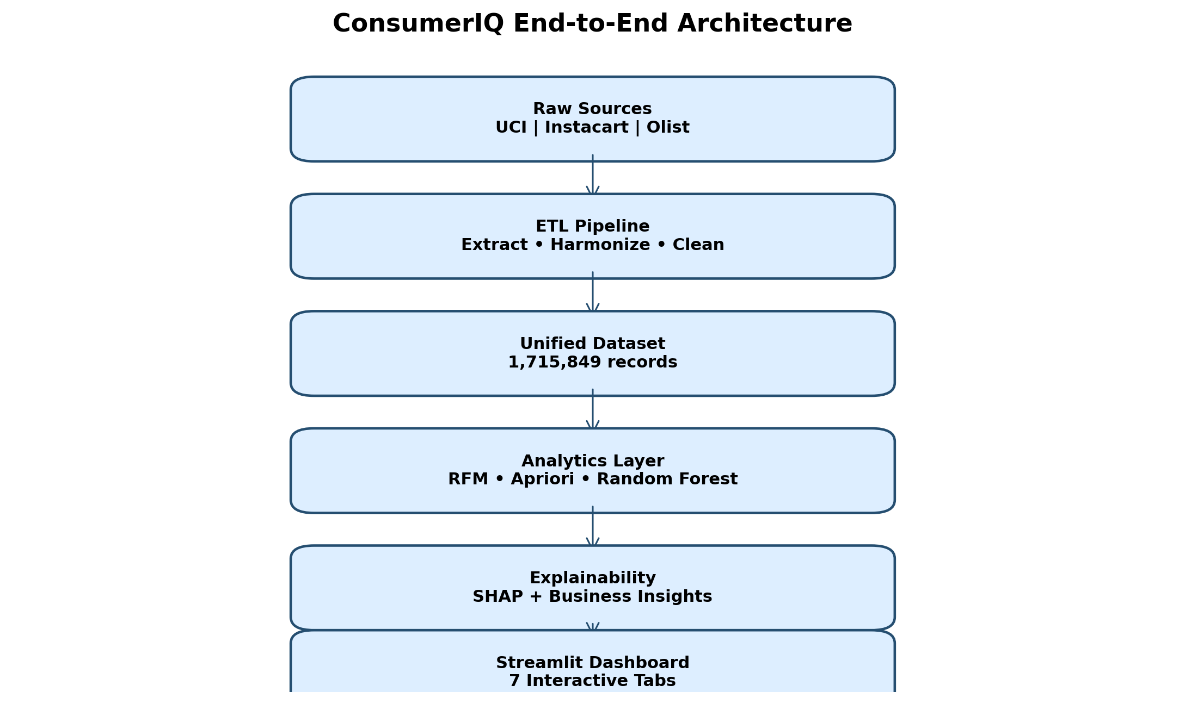
Fig. 1. End-to-end ConsumerIQ system architecture.

3.1 Layered Design
- Data layer: source-specific extraction, cleaning and harmonization for UCI, Instacart and Olist.
- Analytical layer: RFM/K-Means segmentation, Apriori market basket mining, Random Forest churn classification and SHAP explanation.
- Presentation layer: a seven-tab Streamlit dashboard with interactive filters, charts and a churn-probability simulator.

3.2 Unified Data Schema
The unified schema contains dataset_source, order_id, customer_id, order_date, product_id, product_category, quantity, unit_price and total_sales_value. This structure enables common calculations across the sources, including order counts, revenue, customer frequency and category-level summaries.
Field | Purpose
dataset_source | Identifies the original data source
order_id | Unique order or transaction identifier
customer_id | Customer identifier within the source
order_date | Transaction date or constructed order date
product_id | Product-level identifier
product_category | Standardized category or department
quantity | Number of items in the transaction
unit_price | Observed or imputed unit price
total_sales_value | Calculated transaction value
TABLE I. UNIFIED SCHEMA FIELDS

4. DATASETS DESCRIPTION
ConsumerIQ combines three public, independently governed datasets that differ in geography, granularity and pricing structure. Their combination broadens analytical coverage but also introduces comparability limitations discussed in Section 12.

4.1 UCI Online Retail II [4]
The UCI Online Retail II dataset records invoice-level transactions from a UK-based non-store online retailer selling mainly unique all-occasion gifts, covering purchases from predominantly wholesale customers across the United Kingdom and other countries. Each record includes an invoice number, stock code, product description, quantity, invoice date, unit price, customer identifier and country. Cancelled orders are conventionally flagged with a credit-note prefix on the invoice number, and the dataset is known to contain negative quantities, zero prices and missing customer identifiers that require explicit cleaning.

4.2 Instacart Online Grocery Orders [5]
The Instacart dataset, released publicly for the 2017 Instacart Market Basket Analysis competition, contains relational tables of orders, products, aisles and departments for an online grocery ordering and delivery service. Its primary strength is dense, repeated-order behavioral history per user; its primary limitation for revenue analysis is that the released files do not include transaction-level prices, which ConsumerIQ addresses through department-level price imputation (Section 5).

4.3 Olist Brazilian E-Commerce [6]
The Olist dataset covers approximately 100,000 orders placed across multiple Brazilian marketplaces between 2016 and 2018, distributed across linked tables for orders, order items, products, customers, sellers, payments and reviews. It offers rich order-status and logistics metadata not present in the other two sources, but its per-order customer identifiers are known to be order-specific rather than persistent, which affects repeat-customer frequency calculations and is treated as a data-quality caveat in Section 5.2.
Dataset | Rows | Orders | Customers | Revenue / Note
UCI Online Retail II | 805,542 | 36,967 | 5,878 | $17,490,746
Instacart | 798,199 | 80,185 | 8,129 | $3,631,810 (imputed)
Olist | 112,108 | 98,205 | 94,989 | $13,496,408
Unified output | 1,715,849 | 215,357 | 108,996 | $34,618,964 (reported)
TABLE II. SOURCE DATASET SUMMARY
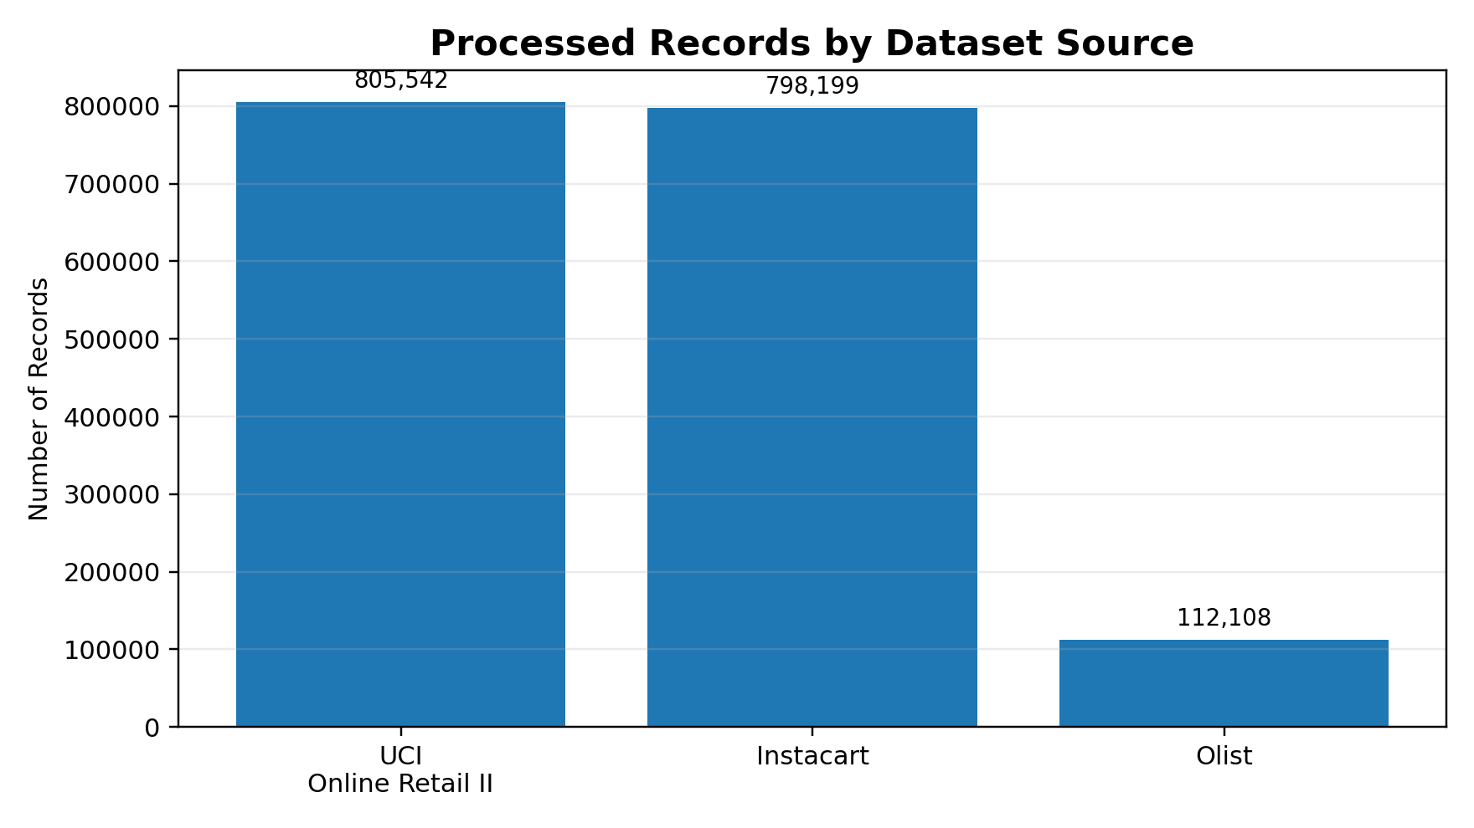
Fig. 2. Processed record counts reported in the project README.
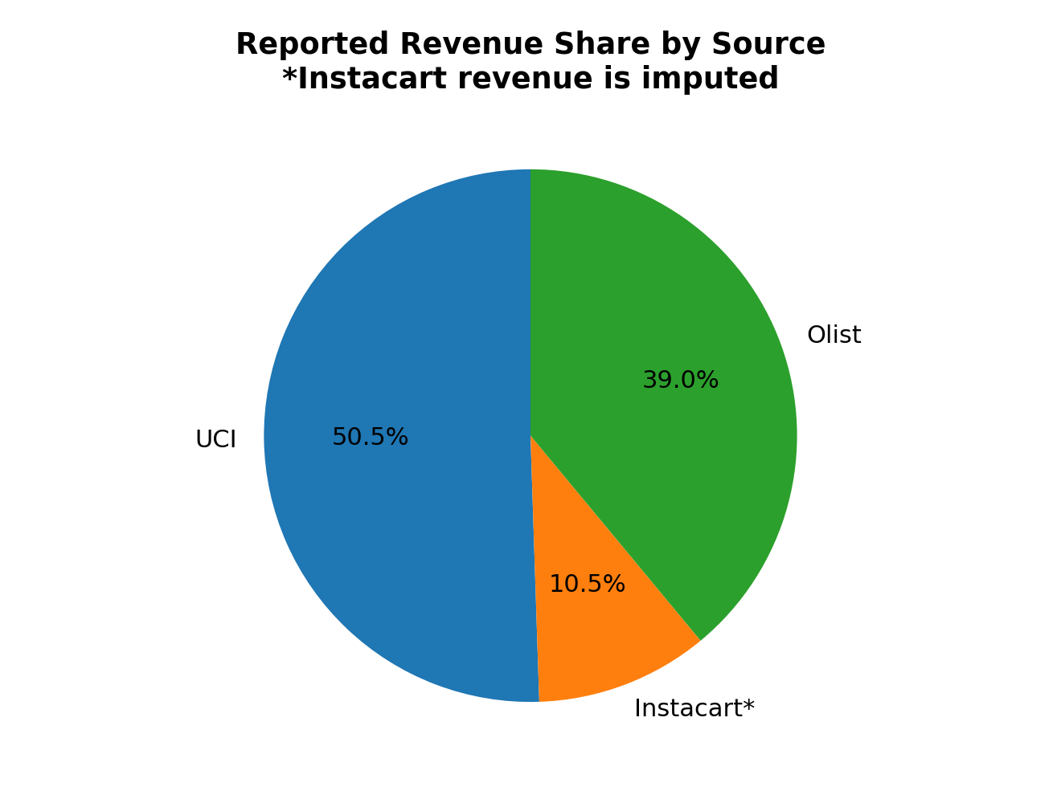
Fig. 3. Reported revenue share; Instacart value is imputed.

5. METHODOLOGY: ETL AND DATA CLEANING
The overall research methodology follows five stages applied uniformly across the three sources: extraction, harmonization, cleaning, transformation and validation, followed by export of a single unified analytical file. The ETL pipeline extracts data from Excel and CSV files, transforms source-specific columns, removes invalid records and exports the unified dataset. UCI records with cancellations, negative quantities, zero prices or missing customer IDs are removed. Olist cancelled orders are excluded and category names are reformatted. Instacart does not contain actual prices in the described files, so department-level price estimates are used [39].
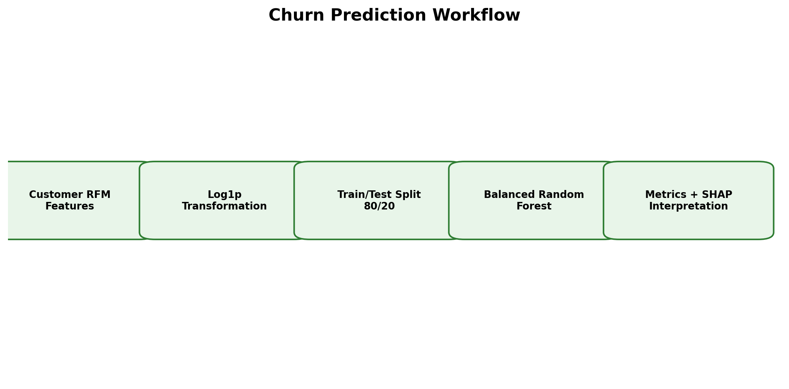
Fig. 4. Methodology and churn-modelling workflow described in the README.

5.1 ETL Stages
- Extraction: read the source files and required columns.
- Harmonization: map different field names into a shared nine-column structure.
- Cleaning: remove cancellations, invalid quantities, zero prices and unusable identifiers where applicable.
- Transformation: standardize dates, categories and transaction-value calculations.
- Validation: inspect missing values, record counts and aggregate metrics.
- Export: save the unified dataset as unified_consumeriq_real.csv.

5.2 Data Quality Considerations
The datasets do not have identical definitions of customers, products or prices. Customer identifiers are source-specific and should not be interpreted as the same individuals across platforms. The Instacart revenue field is an estimate based on department-level prices. Therefore, the unified file is best understood as an integrated analytical dataset rather than a naturally occurring cross-platform customer database.

5.3 Tools and Reproducibility
The pipeline is implemented in Python using pandas for tabular processing, scikit-learn for K-Means and Random Forest, mlxtend-style frequent-itemset routines for Apriori, the SHAP library for TreeExplainer-based interpretation, and Streamlit for the interactive presentation layer, in line with comparable open-source BI tooling reported in the literature [37], [38].

6. EXPLORATORY DATA ANALYSIS
Exploratory data analysis (EDA) in ConsumerIQ serves two purposes: verifying that the ETL output is analytically sound, and surfacing descriptive patterns that contextualize the segmentation, market-basket and churn results presented later. The dashboard provides multiple coordinated views for understanding the distribution, timing and composition of consumer activity across the unified dataset.

6.1 Univariate and Distributional Analysis
For each numeric field in the unified schema — quantity, unit_price and total_sales_value — the EDA module inspects the distribution shape, central tendency and tail behavior before any modelling step. Order values are right-skewed with a long tail of high-value wholesale-style transactions, consistent with the UCI source's wholesale customer base; this skew motivates the log1p transformation applied before RFM clustering and churn feature scaling (Sections 7 and 9). Unit prices show source-specific dispersion, with Instacart's imputed department-level prices exhibiting lower variance than the UCI and Olist observed prices, a direct consequence of the imputation method rather than genuine pricing uniformity.

6.2 Temporal Analysis
The sales and temporal trends tab includes monthly revenue or order volume, weekday patterns and hourly activity through a day-hour heatmap. Temporal aggregation is computed per source before being combined, since each dataset covers a different calendar window and time zone convention; combining raw timestamps without this normalization step would distort month-over-month comparisons. Peak-activity windows identified through the heatmap inform the placement of promotional or retention interventions discussed in Section 12.

6.3 Category and Order-Level Analysis
The category and order distributions tab ranks product categories by both order quantity and revenue contribution, since the two rankings frequently diverge — high-volume categories are not always high-revenue categories, a pattern with direct implications for the market basket rules discussed in Section 8. An order-value histogram is used to inspect the distribution and outliers of order values and to sanity-check the cleaning thresholds applied in Section 5.

6.4 Visualization Design
Visualization | Analytical purpose
Monthly line chart | Identify changes in revenue or order volume over time
Day-hour heatmap | Identify peak shopping windows
Category bar chart | Compare high-volume and high-revenue categories
Order-value histogram | Inspect the distribution and outliers of order values
Revenue-share donut | Show the contribution of each source
Segment bar chart | Compare revenue and customer counts by segment
Lift-confidence scatter | Inspect strength and reliability of association rules
Feature-importance chart | Show model-based feature contribution ranking
TABLE III. DASHBOARD VISUALIZATIONS
The use of multiple chart types supports both executive overview and detailed investigation [38]. Nevertheless, every visualization should include clear labels, units, source information and warnings where values are estimated, particularly for the Instacart imputed-price fields.

6.5 Dashboard Structure
- Dataset Overview and Stats
- Sales and Temporal Trends
- Category and Order Distributions
- Customer Segmentation
- Market Basket Analysis
- Churn Prediction
- Explainable AI

7. CUSTOMER SEGMENTATION USING RFM AND K-MEANS
RFM analysis summarizes customer behavior using Recency, Frequency and Monetary value, consistent with the classical RFM formulation used widely in retail segmentation literature [2], [20]-[23]. Recency is the number of days since the customer's latest order. Frequency is the number of unique orders. Monetary value is the cumulative amount spent by the customer. These measures are calculated separately for each source using a source-specific reference date.

7.1 Clustering Method
The project applies log1p transformation to the RFM variables and uses K-Means clustering with K=4, selected using elbow-method reasoning consistent with [21]. The transformation reduces the influence of highly skewed transaction values identified in Section 6.1. Segment names are assigned dynamically from a composite score using monetary value, frequency and a recency-derived component. This design choice follows the RFP/weighted-RFM literature [19], [20], which reports that adding a composite or profit-weighted score to raw K-Means clusters improves the business interpretability of the resulting segments, though at some distance from the higher Silhouette Scores reported for Hierarchical Clustering on comparable RFM features [22].
RFM measure | Meaning | Business interpretation
Recency | Days since last order | Lower values generally indicate more recent activity
Frequency | Unique order count | Higher values indicate repeated purchasing
Monetary | Cumulative customer spend | Higher values indicate greater historical value
TABLE IV. RFM MEASURES

7.2 Segment Labels
- Champions: high composite customer-value score.
- Loyal Customers: relatively strong repeat purchasing and value.
- At Risk / Potential: customers with weaker or declining engagement indicators.
- Hibernating: customers with low composite scores and limited recent activity.
The labels are descriptive and generated from the project's scoring logic. They should not be treated as universal behavioral truths without validating the cluster profiles and business context.

8. MARKET BASKET ANALYSIS
Market basket analysis is used to discover products or product categories that occur together in the same order, following the classical Apriori formulation [25] and its candidate-generation-free FP-Growth alternative [26]. ConsumerIQ creates a binary basket matrix in which rows represent orders and columns represent categories. The Apriori algorithm identifies frequent itemsets and generates association rules, consistent with retail applications reported in [19]-[30].

8.1 Key Metrics
Metric | Meaning
Support | Frequency with which an itemset occurs in all transactions
Confidence | Conditional likelihood of the consequent given the antecedent
Lift | Observed co-occurrence compared with expected co-occurrence under independence
Conviction | A measure used to assess implication strength
TABLE V. MARKET BASKET METRICS
The dashboard includes support, confidence and lift controls, a scatter plot and a ranked bar chart of rules. As emphasized in [29] and [30], association does not prove causation, and rules should be evaluated for stability, business relevance and possible seasonal effects; redundant-rule pruning techniques such as confidence-improvement filtering [58] offer a path to more concise rule sets in future iterations.

8.2 Practical Use
- Suggest product bundles.
- Identify categories frequently purchased together.
- Support cross-selling campaigns.
- Guide placement of related products.
- Generate hypotheses for controlled marketing experiments.

9. CHURN PREDICTION METHODOLOGY
The project defines churn as customer inactivity beyond 180 days. If the fixed threshold does not create both classes, the implementation uses a percentile-based fallback. The model uses Frequency, Monetary and Average Order Value as predictors. Recency is excluded from the model features because it directly determines the target label and would cause direct target leakage — the same precaution reported in comparable churn studies [16], [17].

9.1 Model Configuration
Component | Configuration
Algorithm | RandomForestClassifier [33]
Number of trees | 200
Maximum depth | 8
Minimum split size | 5
Minimum leaf size | 3
Class weighting | balanced
Random state | 42
Preprocessing | log1p transformation and StandardScaler
Split | 80/20 stratified split as reported
TABLE VI. MODEL CONFIGURATION

9.2 Evaluation Metrics
The evaluation uses accuracy, precision, recall, F1-score, ROC-AUC and a confusion matrix. Since churn is a minority class in the reported experiment, accuracy alone is insufficient, consistent with the class-imbalance concerns raised across the churn-prediction literature [10], [11], [15]. Precision describes the proportion of predicted churners who are actually positive, while recall describes the proportion of actual churners detected by the model.

10. RESULTS AND PERFORMANCE EVALUATION
The numerical values in this section are reported in the supplied README and should be reproduced before final submission.
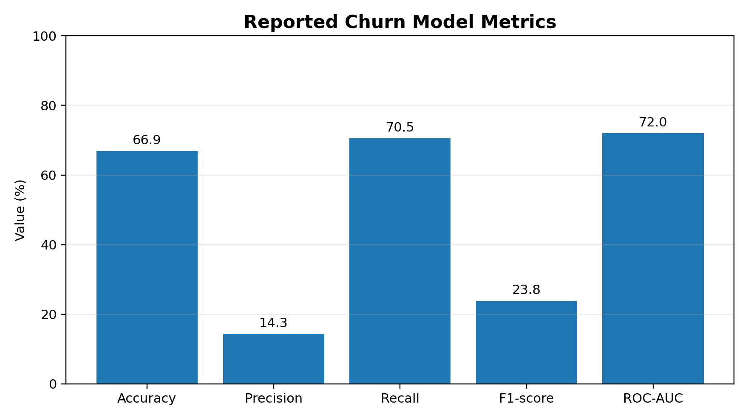
Fig. 5. Reported churn model metrics.
Metric | Reported value
Accuracy | 66.9%
Precision | 14.3%
Recall | 70.5%
F1-score | 0.238
ROC-AUC | 0.720
TABLE VII. CHURN MODEL PERFORMANCE
The model's recall of 70.5% suggests that it detects a substantial proportion of the positive churn class. However, precision of 14.3% indicates that many predicted churners are false positives. In practice, the model may be used as a screening tool for further review, but automated customer actions would require threshold optimization, probability calibration and business-cost analysis.

10.1 Reported Bug Fix
The README describes a class-imbalance issue in which an earlier model produced misleadingly high accuracy while failing to identify the minority class. The use of class_weight='balanced' is reported to have improved recall from 0% to 70.5% and F1-score from 0.000 to 0.238. This illustrates why class-sensitive metrics should accompany accuracy [10], [11].

10.2 Comparison with Existing Methods
To evaluate ConsumerIQ's churn model against the wider literature, Table VIII compares its reported metrics with five published churn-prediction results that use comparable tree-based algorithms. The comparison spans e-commerce and telecom domains because directly comparable multi-source e-commerce churn benchmarks with published precision/recall breakdowns are scarce.
Study / Model | Domain | Algorithm | Acc. | F1 | AUC
Logistic Regression [32] | Telecom | LR | 87.8% | 0.153 | -
Decision Tree [32] | Telecom | DT | 92.2% | 0.614 | -
Random Forest [32] | Telecom | RF | 95.4% | 0.796 | -
XGBoost [32] | Telecom | XGBoost | 96.2% | 0.836 | -
XGBoost e-comm. [35] | E-commerce | XGBoost | 92.4% | 0.906 | 0.941
SHAP ensemble [3] | Telecom | Soft-voting | 84.0% | 0.840 | 0.918
ConsumerIQ (this study) | Multi-source e-comm. | Random Forest | 66.9% | 0.238 | 0.720
TABLE VIII. PERFORMANCE COMPARISON WITH EXISTING CHURN-PREDICTION METHODS
Every comparison study in Table VIII applies explicit class-balancing (SMOTE, resampling) and, in the SHAP-ensemble case [3], threshold optimization at a tuned cutoff of 0.528 — both absent from ConsumerIQ's current configuration beyond class_weight='balanced'. This largely explains the F1-score gap: ConsumerIQ's Random Forest achieves a comparable or higher recall (70.5%) than several baselines but a substantially lower precision (14.3%), producing more false-positive churn alerts per true churner than the tuned literature models. The gap is consistent with, rather than contrary to, the literature's own finding that untuned tree ensembles on imbalanced e-commerce data underperform their resampled and calibrated counterparts [10], [11], [13]. This comparison therefore supports — rather than undermines — ConsumerIQ's stated conclusion that threshold optimization, probability calibration and resampling are necessary next steps before operational deployment (Section 13), while also confirming that Random Forest, as an algorithm family, is an appropriate and literature-consistent choice for this task [33].

11. EXPLAINABLE AI WITH SHAP
ConsumerIQ uses SHAP TreeExplainer [31] to explain Random Forest predictions, following the tree-specific explanation approach validated in [33] as faster and more consistent than model-agnostic KernelSHAP for tree ensembles. Global explanations summarize how features influence model outputs across a sample, while local explanations describe the factors contributing to an individual prediction. The dashboard provides a global beeswarm summary and local waterfall visualizations.

11.1 Global and Local Explanations
- Global SHAP summary: identifies broad feature patterns across customers.
- Local waterfall plot: explains a single customer prediction.
- Raw feature display: shows understandable values alongside transformed model values.
- Business insights panel: translates model behavior into plain-language interpretation.
Explainability is useful because a churn score without a reason can be difficult for business users to trust [3], [32]. However, SHAP values describe the model's behavior and should not automatically be interpreted as causal effects. Explanations must be reviewed for stability and consistency.

11.2 Simulator
The README describes a real-time simulator that accepts frequency and monetary inputs and returns churn probability, risk tier, average order value and a retention recommendation. The reported verification case uses frequency 33 and monetary value $2,380, with an expected low-risk result. This test should be re-run against the final model and environment.

12. DISCUSSION
ConsumerIQ demonstrates an integrated approach to consumer analytics. Descriptive visualizations provide a broad view of performance, RFM segmentation supports customer profiling, market basket analysis reveals product relationships, and churn prediction supports retention-oriented screening. SHAP adds an interpretation layer that can make model outputs more accessible to non-technical users [3], [32]. Positioned against the eighteen studies reviewed in Section 2, ConsumerIQ's contribution is architectural breadth — combining ETL, segmentation, association mining, prediction and explanation in one reproducible pipeline — rather than state-of-the-art predictive accuracy, which Table VIII shows still trails tuned, resampled literature baselines.
The reported metrics show that improving minority-class recall can come with a precision trade-off, a pattern also visible across the comparison studies in Table VIII. Whether this trade-off is acceptable depends on the cost of contacting a customer, the cost of missing a customer who is likely to leave and the action taken after an alert [15]. A retention model should therefore be evaluated using business-specific measures rather than generic metrics alone.

12.1 Limitations
- Churn is defined using inactivity rather than confirmed customer departure.
- A percentile fallback can change the meaning of the churn label.
- Instacart revenue is estimated through department-level price imputation.
- The reported split is stratified but not explicitly time-based, unlike temporal-validation recommendations in the literature [10], [11].
- Low precision requires threshold tuning and calibration, as demonstrated by the higher-precision comparison models in Table VIII.
- The datasets differ in geography, time period, category structure and customer identity.
- Olist customer identifiers are order-specific rather than persistent, affecting frequency calculations (Section 4.3).
- The supplied README does not contain every detail needed for complete reproducibility.

13. FUTURE SCOPE
- Use temporal train-test validation to simulate real deployment [10], [11].
- Compare Random Forest with Logistic Regression, gradient boosting (XGBoost, LightGBM) and survival-analysis approaches, following the algorithm comparisons in [12], [32], [35], [36].
- Tune the decision threshold using precision-recall and business-cost objectives, following the 0.528-cutoff approach in [3].
- Apply class-balancing techniques such as SMOTE, reported to substantially improve precision-recall trade-offs in comparable studies [10], [13].
- Add behavioral features such as purchase intervals and category preference changes.
- Evaluate probability calibration and model drift.
- Test explanation stability across customer segments and time periods.
- Add monitoring and scheduled retraining.
- Conduct user studies to evaluate dashboard usability, extending the goal-based BI design framework in [38].
- Validate association rules on separate time periods and apply redundant-rule pruning [58].
- Explore Hierarchical Clustering as an alternative to K-Means for RFM segmentation, given its reported Silhouette Score advantage [22].
- Assess whether retention recommendations improve outcomes through controlled experiments.

14. CONCLUSION
This paper presented ConsumerIQ, a unified e-commerce intelligence dashboard combining ETL, exploratory data analysis, RFM segmentation, market basket analysis, Random Forest churn prediction and SHAP-based explainability, positioned against a review of eighteen related studies in churn prediction, segmentation, association mining and explainable AI. The supplied project documentation reports a unified dataset containing more than 1.7 million records and a churn model with 70.5% recall and 0.720 ROC-AUC. Benchmarked against five comparable published results, the model shows competitive recall but lower precision than tuned, resampled literature baselines, indicating that further validation is required before operational use.
The project's main contribution is the integration of established analytical techniques — each individually well studied in the literature reviewed in Section 2 — into a single, accessible, reproducible Streamlit dashboard with a transparent multi-source ETL layer. Future improvements should focus on temporal validation, improved churn definitions, calibration, richer features and business-cost evaluation. ConsumerIQ provides a practical, literature-grounded prototype for combining data visualization, machine learning and explainable analytics in a consumer-focused setting.

REFERENCES
[1] I. Boukrouh and A. Azmani, "Explainable machine learning models applied to predicting customer churn for e-commerce," IAES International Journal of Artificial Intelligence, vol. 14, no. 1, pp. 286–297, 2025.
[2] M. Zaghloul, S. Barakat, and A. Rezk, "Enhancing customer retention in Online Retail through churn prediction: A hybrid RFM, K-means, and deep neural network approach," Expert Systems with Applications, 2025.
[3] A. El Attar and M. El-Hajj, "Explainable AI-driven customer churn prediction: a multi-model ensemble approach with SHAP-based feature analysis," Frontiers in Artificial Intelligence, vol. 9, art. 1748799, 2026.
[4] UCI Machine Learning Repository, "Online Retail II Dataset," University of California, Irvine.
[5] Instacart, "Instacart Market Basket Analysis," Kaggle dataset, 2017.
[6] Olist, "Brazilian E-Commerce Public Dataset by Olist," Kaggle dataset.
[7] ConsumerIQ project README and supplied project documentation, 2026.
[8] "Customer Churn Prediction on E-Commerce Using Machine Learning," International Journal for Research in Applied Science & Engineering Technology (IJRASET), 2023.
[9] "Prediction of Customer Churn for an E-Commerce Company Using Machine Learning," 2026.
[10] "Customer Churn Prediction: A Systematic Review of Recent Advances, Trends, and Challenges in Machine Learning and Deep Learning," Big Data and Cognitive Computing, vol. 7, no. 3, art. 105, 2025.
[11] "Prediction of Customer Churn for an E-Commerce Company Using Machine Learning" (systematic review of 214 studies, 2015–2023), 2026.
[12] "Predicting Customer Churn in E-Commerce Using Machine Learning: A Comprehensive Approach," International Journal of Informatics and Information Systems, vol. 9, no. 2, pp. 357–370, 2026.
[13] N. Ahmad, M. J. Awan, H. Nobanee, A. M. Zain, A. Naseem, and A. Mahmoud, "Customer Personality Analysis for Churn Prediction Using Hybrid Ensemble Models and Class Balancing Techniques," IEEE Access, vol. 12, pp. 1865–1879, 2024.
[14] R. E. Bawack, S. F. Wamba, K. D. A. Carillo, and S. Akter, "Artificial intelligence in E-Commerce: A Bibliometric Study and Literature Review," Electronic Markets, vol. 32, no. 1, pp. 297–338, 2022.
[15] A. Manzoor, M. A. Qureshi, E. Kidney, and L. Longo, "A review on machine learning methods for customer churn prediction and recommendations for business practitioners," IEEE Access, vol. 12, pp. 70434–70463, 2024.
[16] H. J. Lee and S. B. Cho, "Machine learning-based customer churn prediction in home appliance rental business," Expert Systems with Applications, vol. 150, art. 113255, 2020.
[17] N. T. Lee, H. C. Lee, J. Hsin, and S. H. Fang, "Prediction of customer behavior changing via a hybrid approach," IEEE Open Journal of the Computer Society, vol. 5, pp. 27–38, 2024.
[18] S. J., C. Gangadhar, R. K. Arora, P. Renjith, J. Bamini, and Y. D. Chincholkar, "E-commerce customer churn prevention using machine learning-based business intelligence strategy," Measurement: Sensors, vol. 27, 2023.
[19] P. Li et al., "An E-commerce Customer Segmentation Method based on RFM Weighted K-means," 2022.
[20] "Customer Segmentation Using RFM and K-Means Clustering to Support CRM in Retail Industry," 2025.
[21] "RFM Analysis Using K-means Algorithm for Customer Segmentation," Springer Nature, 2024.
[22] "Exploring Customer Segmentation in E-Commerce using RFM Analysis with Clustering Techniques," Journal of Telecommunications and the Digital Economy, vol. 12, no. 3, pp. 97–125, 2024.
[23] R. Srivastava, "Identification of customer clusters using RFM model: a case of diverse purchaser classification," International Journal of Business Analytics.
[24] "Research on optimization of personalized recommendation method based on RFMQ model — taking outdoor sports products in cross-border e-commerce as an example," 2025.
[25] R. Agrawal and R. Srikant, "Fast algorithms for mining association rules," in Proc. 20th Int. Conf. Very Large Data Bases (VLDB), 1994.
[26] J. Han, J. Pei, and Y. Yin, "Mining frequent patterns without candidate generation," in Proc. ACM SIGMOD Int. Conf. on Management of Data, 2000.
[27] A. Jadhav, A. Jadhav, and R. D. Jadhav, "Association Rule Mining in Retail: Exploring Market Basket Analysis with Apriori Algorithm," SSRN, 2023.
[28] M. Çatkın, Ş. Yüksel, A. K. Konyalıoğlu, T. Apaydın, and T. Özcan, "Market Basket Analysis Using Apriori and Eclat Algorithm in an E-Commerce Company," Springer Nature, 2025.
[29] "Apriori Algorithm and Market Basket Analysis to Uncover Consumer Buying Patterns: Case of a Kenyan Supermarket," 2024.
[30] "Association rule mining algorithm implementation for e-commerce in the retail sector," 2024.
[31] S. M. Lundberg and S. I. Lee, "A unified approach to interpreting model predictions," in Proc. 31st Conf. on Neural Information Processing Systems (NeurIPS), 2017.
[32] "Explainable Artificial Intelligence for Customer Churning Prediction in Banking," CEUR Workshop Proceedings, vol. 3026, paper 17.
[33] L. Breiman, "Random forests," Machine Learning, vol. 45, no. 1, pp. 5–32, 2001.
[34] "Explainable artificial intelligence for Healthcare applications using Random Forest Classifier with LIME and SHAP," 2023.
[35] "Implementing XGBoost Model for Predicting Customer Churn in E-Commerce Platforms," 2026.
[36] "Enhancing customer retention with machine learning: A comparative analysis of ensemble models for accurate churn prediction," 2025.
[37] T. Kandadi, "An Interactive Sales Analytics Dashboard Using Streamlit: A Lightweight Alternative to Traditional BI Tools," SSRN, 2025.
[38] "Visualization Requirements for Business Intelligence Analytics: A Goal-Based, Iterative Framework," 2024.
[39] "Big-ETL: extracting-transforming-loading approach for Big Data," 2018.
[40] T. Chen and C. Guestrin, "XGBoost: A scalable tree boosting system," in Proc. 22nd ACM SIGKDD Int. Conf. on Knowledge Discovery and Data Mining, 2016.
[41] "From redundant association rules to product networks: A scalable confidence-improvement pruning and Maximum Spanning Tree approach," 2025.

APPENDIX A. REPRODUCIBILITY CHECKLIST
- Verify the exact dataset versions and download sources.
- Run the ETL pipeline and confirm record counts.
- Confirm revenue calculations and Instacart imputation assumptions.
- Re-run the churn model with the documented configuration.
- Save the confusion matrix, ROC curve and precision-recall curve.
- Check that SHAP explanations match the final model.
- Insert final dashboard screenshots if required by faculty.
- Verify every DOI and reference manually.
- Use the faculty's required template and citation style.
- Review the final paper for accuracy, originality and consistent terminology.

APPENDIX B. AUTHOR CONTRIBUTION TEMPLATE
Contributor | Suggested contribution areas
P. Aashish | Data integration, dashboard development, analysis and paper preparation
P. Umesh | Data preparation, testing, visualization review and documentation
TABLE IX. AUTHOR CONTRIBUTIONS
The contribution descriptions should be edited to reflect the actual work completed by each team member.

